SOFTWARE DESIGN AND ARCHITECTURE

Submitted to: Sir Mukhtiyar zamin


ASSIGNMENT 1

Submitted by: Fatima Khan
Roll no: SP23-BSE-102
Date: 2nd may 2025

CHAPTER NO: 1 “ANALYSIS”
USE CASE DISGRAM
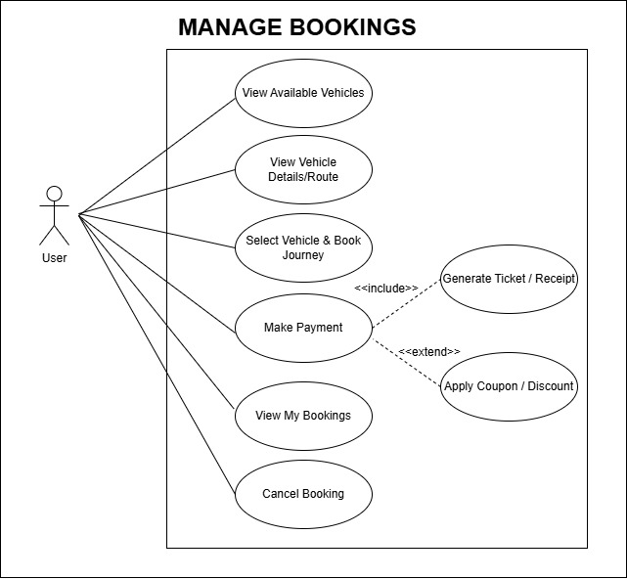
FULLY DRESSES USE CASES
CONFIRM BOOKING
Use case ID | 1
Use case name | Confirm booking
Actors | Primary: user, customer secondary: Transport Management System (TMS), Payment Gateway, Admin
Description | This use case describes the process by which a customer confirms a transport service booking (such as a seat on a bus, a cargo shipment, or a taxi), after selecting transport details and entering required information.
Trigger | The customer has completed selecting transport details and clicks the "Confirm Booking" button.
Pre-conditions | Pre-1: The user is logged in or has provided necessary personal details.  Pre-2 The user has selected a valid transport route/service.  Pre-3: The system shows the availability of the selected service.  Pre-4: All required fields are completed.
Post conditions: | On Success:  Post-1: Booking is confirmed.  Post-2: Transport seat is reserved  Post-3: Confirmation message with booking ID is sent to the user.  Post-4: Booking details are stored in the system for further processing.  On Failure:  Post-1: Booking is not confirmed  Post-2: Appropriate error message is shown to the user (e.g., payment failure, route full).
Normal flow | 1.0: Customer logs into the TMS.  1: Customer selects transport service.  2: the users will be able to see the available vehicles list  3: The user scrolls through list as needed.  4: The user will clicks on a vehicle to select it.  5: The system loads and displays the detailed information for the selected vehicle.  6: The user reviews the vehicle details and may proceed to take further actions.  7: Customer clicks on "Confirm Booking".  8: TMS verifies seat/cargo space availability.  9: TMS redirects to payment gateway.  10: Customer provides payment information and submits.  11: Payment is authorized and confirmed.  12: TMS stores the booking information and marks the transport unit as partially/fully booked.  13: Booking confirmation with unique ID is displayed to the user.  14: Confirmation is sent via email/SMS.
Alternative flow | 1: Vehicle is no longer available  1(a): The user clicks on a vehicle.  1(b): The system checks availability and finds the vehicle has been removed or is no longer available.  1(c): The system displays a message: “This vehicle is no longer available.”  1(d): The user is returned to the list or shown similar vehicle suggestions.  2: System fails to load confirmation details  2(a): The user selects a vehicle.  2(b): The system encounters an error loading the vehicle’s confirmation details (e.g., server issue).  2(c): The system displays an error message: “Unable to load vehicle confirmation details. Please try again later.”  2(d): The user may try selecting a different vehicle or refresh the
Exception | 1:Network Error or Timeout  1(a): The system fails to respond due to a slow or lost internet connection.  1(b): Message: “Network error. Please check your connection and try again.”  1(c): The user will be given the option to retry.  2: Session Timeout  2(a): The user's session has expired due to inactivity.  2(b): Message: “Your session has expired. Please log in again.”  2(c): The user is redirected to the login page.  3: Data Corruption or Incomplete Vehicle Record  3(a): The selected vehicle’s data is missing or corrupted (e.g., no image, missing details).  3(b): Message: “Vehicle details are currently unavailable.”  3(c): The user is advised to choose a different vehicle.  4: Vehicle Selection Conflict (Multiple Users)  4(a): The vehicle is selected by another user at the same time, leading to a conflict (e.g., in case of reservations or limited stock).  4(b): Message: “This vehicle is no longer available due to a simultaneous selection by another user.”  4©: The user is given the option to view similar available vehicles or return to the search results  5: Payment Failure  5(a): Payment gateway declines the transaction.  5(b): TMS shows an error and allows the user to retry payment.  5©: Booking is not stored or confirmed.  6: Slot/Seat Unavailable During Confirmation  6(a): Another user books the same slot/seat in parallel.  6(b): TMS notifies the user of unavailability.  6©: TMS allows user to choose another option.
Business rules | - Availability Check  - A vehicle must be marked as available before it can be selected. If the vehicle is rented, sold, or unavailable, it should not appear in the list of selectable vehicles.  - Vehicle Details Accuracy  - The system must ensure that all vehicle details (e.g., make, model, year, price, and features) are up-to-date and accurate. If the information is outdated or missing, the vehicle cannot be selected until updated.  - One Vehicle Selection per User at a Time  - A user can select only one vehicle at a time for viewing detailed information. If the user wants to compare multiple vehicles, the system must allow adding vehicles to a comparison list, but not for direct selection.  - Session Persistence  - If a user selects a vehicle, the system must remember their selection within the session (or for a limited time) until they decide to take further action (e.g., booking or inquiry).  - Real-Time Updates  - The vehicle’s status (e.g., availability) must be updated in real-time. If a vehicle is rented or sold while the user is viewing its details, the system should reflect this immediately.  - Data Integrity for Selected Vehicles  - Once a vehicle is selected, the system must verify that all the associated data (e.g., images, features, pricing) is correct and loaded to prevent errors in the selection process.  - Reservation Conflicts  - If a user selects a vehicle that is under reservation or pending, the system should display a notification regarding the potential conflict and allow the user to proceed with selecting a different vehicle or holding the vehicle.
Assumptions | • The User is Logged In (If Required)  - If the selection of vehicles requires a user account (for saving preferences, booking, etc.), the user is assumed to be logged in before they can select a vehicle.  • The Vehicle Database is Up-to-Date  - The system assumes that the vehicle database is continuously updated with the most current inventory, availability, pricing, and other related information.  • Sufficient Internet Connection  - It’s assumed that the user has a stable internet connection for the vehicle listing and selection process to be seamless. A slow or disconnected connection could cause delays in the vehicle selection or viewing process.  • Vehicles are Properly Categorized  - The vehicles in the system are categorized correctly (e.g., by make, model, type, availability) to allow for effective searching and selection.  • Availability of Vehicle Information  - It is assumed that all relevant vehicle information (e.g., specifications, images, availability, pricing) is properly populated and available to the user at the time of selection.  • The System Can Handle Simultaneous Users  - The system is capable of managing multiple users selecting and viewing vehicles at the same time without performance degradation or data conflicts.  • The Vehicle’s Availability is Real-Time  - It’s assumed that vehicle availability status (e.g., available, reserved, out of stock) is updated in real-time, ensuring the user sees the most accurate and current status when selecting a vehicle.

MAKE PAYMENT
Use case ID | 2
Use case name | Make payment
Actors | Primary: user, customer secondary: Payment Gateway (e.g., Stripe, PayPal, etc.), Bank System (for verifying and processing transactions), admin.
Description | This use case describes the process by which a customer completes payment for a transportation-related service, such as booking a shipment, purchasing a ticket, or scheduling a delivery. The system verifies payment details, processes the transaction, and confirms the service booking.
Trigger | The customer initiates payment after selecting a transportation service (e.g., delivery, freight booking, ticket reservation).
Pre-conditions | Pre-1: Customer is registered and logged into the TMS platform  Pre-2: A valid service (shipment, route, vehicle, delivery schedule) has been selected  Pre-3: The system has calculated total charges including taxes and any additional fees.  Pre-4: A payment method is available and supported by the system.
Post conditions: | Post-1: Payment is successfully processed and recorded.  Post-2: A booking or shipping order is confirmed.  Post-3:. A receipt and confirmation details are sent to the customer.  Post-4: TMS updates the vehicle/route availability and resource status.  Post-5: Transaction log is stored in the system
Normal flow | 1.0: Customer selects a transport service and proceeds to checkout.  1: System displays the payment summary including service charges, taxes, and discounts.  2: Customer selects a payment method and enters payment details.  3: System validates the entered information.  4: System sends the payment request to the payment gateway.  5: Payment gateway confirms successful transaction.  6: TMS marks the booking as “Paid” and sends confirmation to the customer.  7: System updates internal schedules, routes, or driver assignments.  8: A receipt is emailed and optionally downloadable from the dashboard.
Alternative flow | 1: Customer Applies Promo Code or Discount  1(a): At step 2, customer applies a valid promo code.  1(b): System recalculates the total and continues with the flow.  2: System fails to load confirmation details  2(a): The user selects a vehicle.  2(b): The system encounters an error loading the vehicle’s confirmation details (e.g., server issue).  2(c): The system displays an error message: “Unable to load vehicle confirmation details. Please try again later.”  2(d): The user may try selecting a different vehicle or refresh the  System recalculates the total and continues with the flow.  3: Customer Changes Payment Method  3(a): At step 3, customer switches to a different method (e.g., from card to wallet).  3(b): System reloads the form and continues.
Exception | 1:Network Error or Timeout  1(a): The system fails to respond due to a slow or lost internet connection.  1(b): Message: “Network error. Please check your connection and try again.”  1(c): The user will be given the option to retry.  2: Session Timeout  2(a): The user's session has expired due to inactivity.  2(b): Message: “Your session has expired. Please log in again.”  2(c): The user is redirected to the login page.  3: Data Corruption or Incomplete Vehicle Record  3(a): The selected vehicle’s data is missing or corrupted (e.g., no image, missing details).  3(b): Message: “Vehicle details are currently unavailable.”  3(c): The user is advised to choose a different vehicle.  4: Payment Failure  4(a): Payment gateway declines the transaction.  4(b): TMS shows an error and allows the user to retry payment.  4©: Booking is not stored or confirmed.  4(d): if payment details are invalid, system shows an error.  4(e): Customer can re-enter or change the method.  5: Insufficient Funds or Declined Transaction  5(a): if transaction is declined by bank the Customer is notified and can try again or use a different method.
Business rules | • Payment must be made in full before any transport service is confirmed.  • Payment methods accepted include major credit/debit cards, UPI, wallets, and net banking.  • Taxes and service charges must be clearly shown before payment.  • Cancellation and refund policies must be visible before confirmation.  • Corporate clients may use wallet/credit limit (if supported by system policy).
Assumptions | • The User is Logged In (If Required)  - If the selection of vehicles requires a user account (for saving preferences, booking, etc.), the user is assumed to be logged in before they can select a vehicle.  • The Vehicle Database is Up-to-Date  - The system assumes that the vehicle database is continuously updated with the most current inventory, availability, pricing, and other related information.  • Sufficient Internet Connection  - It’s assumed that the user has a stable internet connection for the vehicle listing and selection process to be seamless. A slow or disconnected connection could cause delays in the vehicle selection or viewing process.  • Availability of Vehicle Information  - It is assumed that all relevant vehicle information (e.g., specifications, images, availability, pricing) is properly populated and available to the user at the time of selection.  • The System Can Handle Simultaneous Users  - The system is capable of managing multiple users selecting and viewing vehicles at the same time without performance degradation or data conflicts.  • The Vehicle’s Availability is Real-Time  - It’s assumed that vehicle availability status (e.g., available, reserved, out of stock) is updated in real-time, ensuring the user sees the most accurate and current status when selecting a vehicle.

GENERATE RECEIPT
Use case ID | 3
Use case name | Generate receipt
Actors | Primary: system secondary: Customer (initiates or receives the receipt), Admin or Transport Operator (may request receipt generation), Payment Gateway (provides transaction reference)
Description | This use case allows the system to automatically or manually generate a receipt after a successful payment for transport services. The receipt includes transaction details, customer information, service summary, and a unique receipt number.
Trigger
Pre-conditions | Pre-1: Payment has been successfully completed.  Pre-2: A booking or service order exists in the system.  Pre-3: Customer and transaction data are stored.
Post conditions: | Post-1: A digital receipt (PDF or email format) is generated.  Post-2: The receipt is saved in the system for future reference.  Post-3:. A receipt and confirmation details are sent to the customer.  Post-4:. The customer receives a copy via email or downloads it from their dashboard.
Normal flow | 1.0:. Payment is confirmed by the system (from “Make Payment” use case).  1: Payment is confirmed by the system (from “Make Payment” use case).  2: A unique receipt number is generated.  3: Receipt is formatted with all necessary details:  - Customer name and ID  - Payment amount and date  - Service booked (shipment, ticket, delivery, etc.)  - Payment method and transaction ID  - Company/tax information (if applicable)  - Terms and conditions  4: The receipt is saved to the database or receipt repository.  5: The receipt is sent to the customer via email or made available for download.  6: A confirmation message is displayed to the user.
Alternative flow | 1: Admin Requests Duplicate Receipt  1(a): Admin searches for a specific transaction.  1(b): System regenerates or retrieves the existing receipt.  1(c): Admin can print, download, or email the receipt.  2: Customer Requests Receipt from History  2(a): Customer navigates to their transaction history.  2(b): System shows receipt download options for completed payments.  3: System fails to load confirmation details  3(a): The user selects a vehicle.  3(b): The system encounters an error loading the vehicle’s confirmation details (e.g., server issue).  3(c): The system displays an error message: “Unable to load vehicle confirmation details. Please try again later.”  3(d): The user may try selecting a different vehicle or refresh the  System recalculates the total and continues with the flow.
Exception | 1:Network Error or Timeout  1(a): The system fails to respond due to a slow or lost internet connection.  1(b): Message: “Network error. Please check your connection and try again.”  1(c): The user will be given the option to retry.  2: Session Timeout  2(a): The user's session has expired due to inactivity.  2(b): Message: “Your session has expired. Please log in again.”  2(c): The user is redirected to the login page.  3: Data Corruption or Incomplete Vehicle Record  3(a): The selected vehicle’s data is missing or corrupted (e.g., no image, missing details).  3(b): Message: “Vehicle details are currently unavailable.”  3(c): The user is advised to choose a different vehicle.  4: Payment Failure  4(a): Payment gateway declines the transaction.  4(b): TMS shows an error and allows the user to retry payment.  4©: Booking is not stored or confirmed.  4(d): if payment details are invalid, system shows an error.  4(e): Customer can re-enter or change the method.  5: Insufficient Funds or Declined Transaction  5(a): if transaction is declined by bank the Customer is notified and can try again or use a different method.
Business rules | • Payment must be made in full before any transport service is confirmed.  • Payment methods accepted include major credit/debit cards, UPI, wallets, and net banking.  • Taxes and service charges must be clearly shown before payment.  • A receipt must only be generated for successfully completed payments.  • Each receipt must have a unique, traceable receipt ID.  • Receipt must comply with legal and tax requirements (e.g., GST, VAT).  • Receipts should be stored securely and available for future reference.  • Admins should not be able to alter transaction amounts from the receipt screen.
Assumptions | • The User is Logged In (If Required)  - If the selection of vehicles requires a user account (for saving preferences, booking, etc.), the user is assumed to be logged in before they can select a vehicle.  • The Vehicle Database is Up-to-Date  - The system assumes that the vehicle database is continuously updated with the most current inventory, availability, pricing, and other related information.  • Sufficient Internet Connection  - It’s assumed that the user has a stable internet connection for the vehicle listing and selection process to be seamless. A slow or disconnected connection could cause delays in the vehicle selection or viewing process.  • Availability of Vehicle Information  - It is assumed that all relevant vehicle information (e.g., specifications, images, availability, pricing) is properly populated and available to the user at the time of selection.  • The System Can Handle Simultaneous Users  - The system is capable of managing multiple users selecting and viewing vehicles at the same time without performance degradation or data conflicts.  • The Vehicle’s Availability is Real-Time  - It’s assumed that vehicle availability status (e.g., available, reserved, out of stock) is updated in real-time, ensuring the user sees the most accurate and current status when selecting a vehicle.

SYSTEM SEQUENCE DIAGRAM
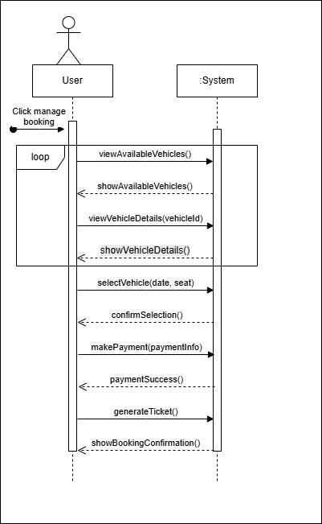

CHAPTER 2: “SOFTWARE ARCHITECTURE”
PACKAGE DIAGRAM
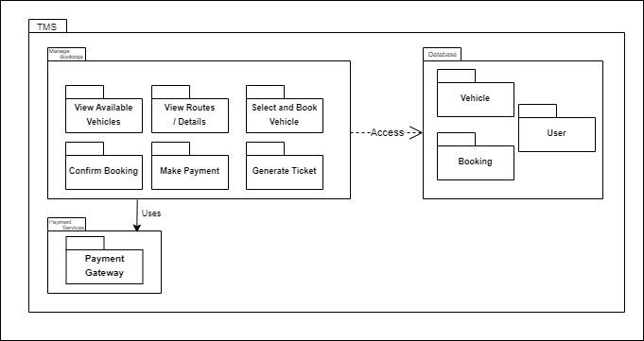

CHAPTER NO: 3 “DESIGNING ARCHITECTURE”
COMMUNICATION DIAGRAM
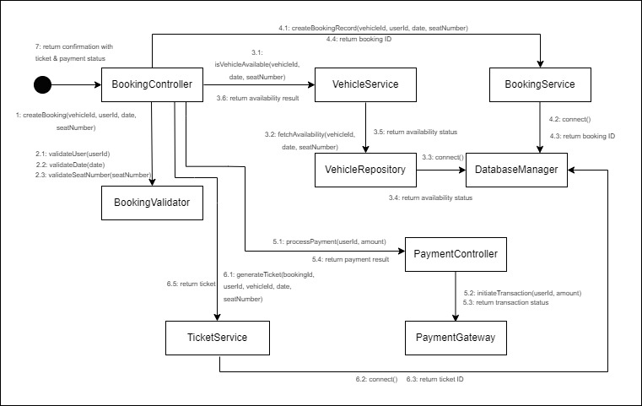

CLASS DIAGRAM
